1. **ReactJS-HOL**

**Create StudentApp React App with 3 Components**

# Step 1: Open VS Code and Create React App

* 1. Open VS Code
  2. Open a **new folder** where you want to create your app.
  3. Open the terminal in VS Code: Terminal → New Terminal
  4. Run this command:

npx create-react-app studentapp

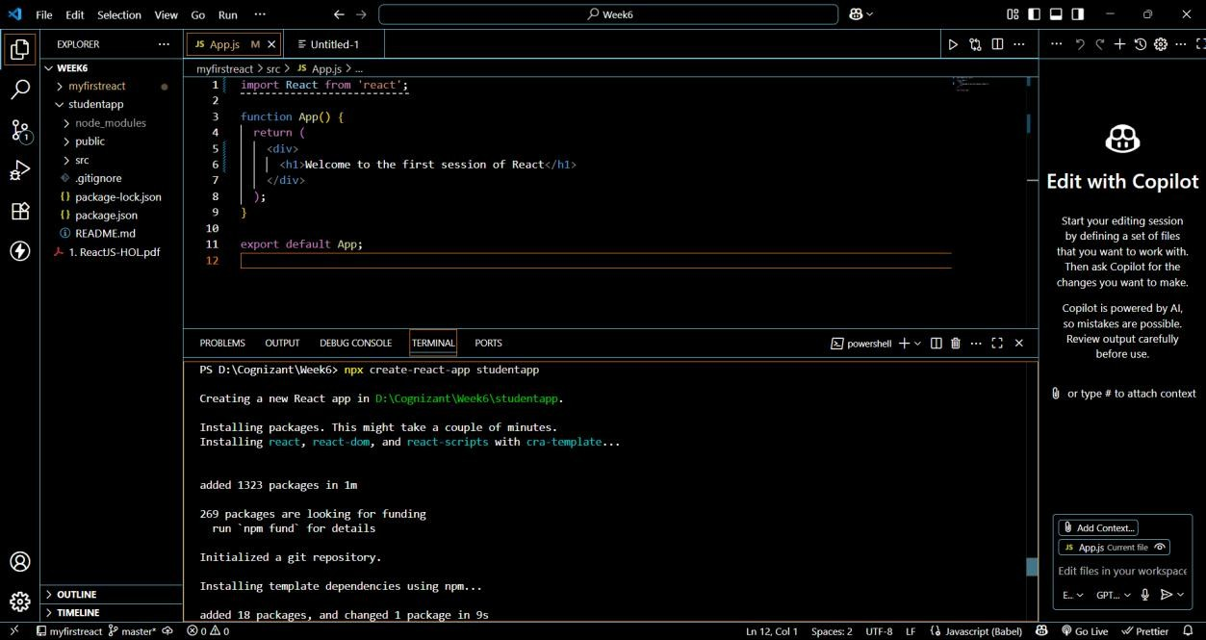

# Step 2: Move Into the Project Folder

cd studentapp

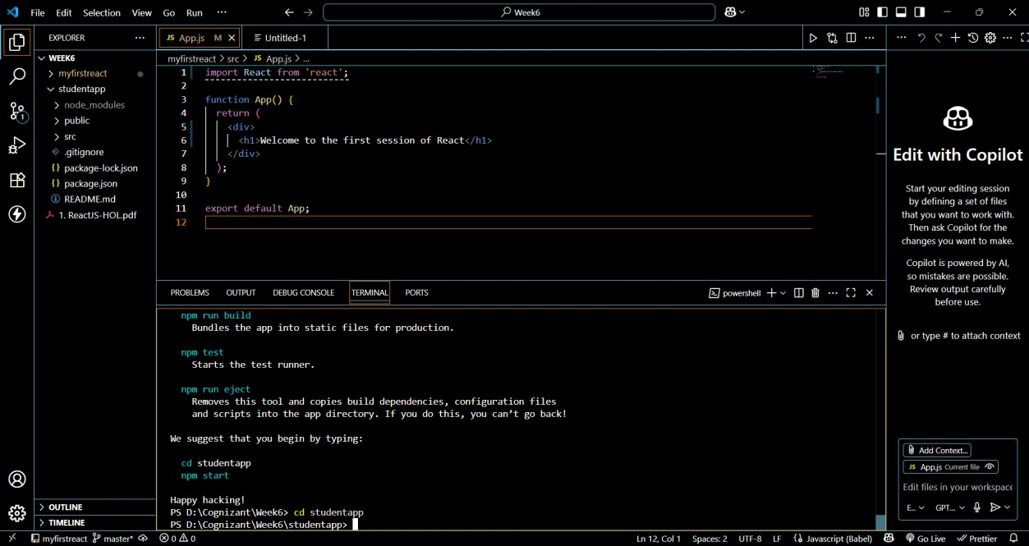

# Step 3: Create a Folder for Components

In the src folder:

1. Right-click → **New Folder** → Name it Components **Step 4: Create Home.js Component (Class Component)** In src/Components/Home.js, add:

import React, { Component } from 'react';

class Home extends Component { constructor(props) { super(props);

}

render() {

return <h2>Welcome to the Home page of Student Management Portal</h2>;

}

}

export default Home;

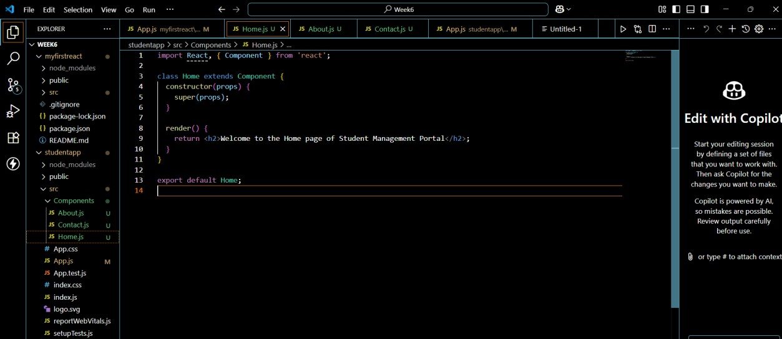

# Step 5: Create About.js Component (Class Component)

In src/Components/About.js, add:

import React, { Component } from 'react';

class About extends Component { constructor(props) { super(props);

}

render() {

return <h2>Welcome to the About page of the Student Management Portal</h2>;

}

}

export default About;

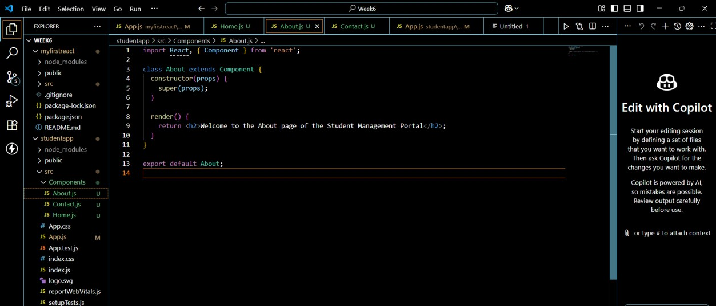

# Step 6: Create Contact.js Component (Class Component)

In src/Components/Contact.js, add: import React, { Component } from 'react';

class Contact extends Component { constructor(props) {

super(props);

}

render() {

return <h2>Welcome to the Contact page of the Student Management Portal</h2>;

}

}

export default Contact;

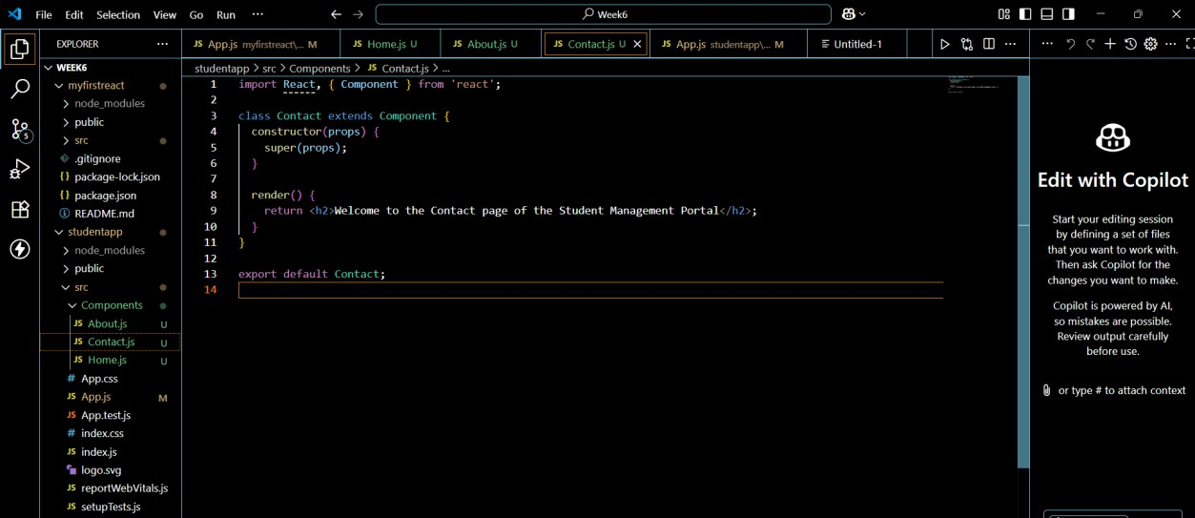

# Step 7: Edit App.js to Use the Components

In src/App.js, replace everything with: import React from 'react';

import Home from './Components/Home';

import About from './Components/About'; import Contact from './Components/Contact';

function App() { return (

<div>

<h1>Student Management Portal</h1>

<Home />

<About />

<Contact />

</div>

);

}

export default App;

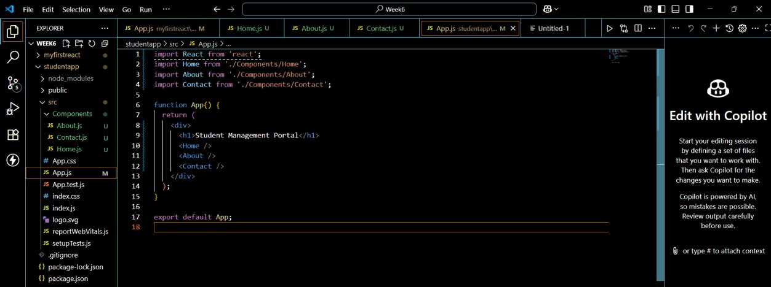

# Step 8: Run the React App

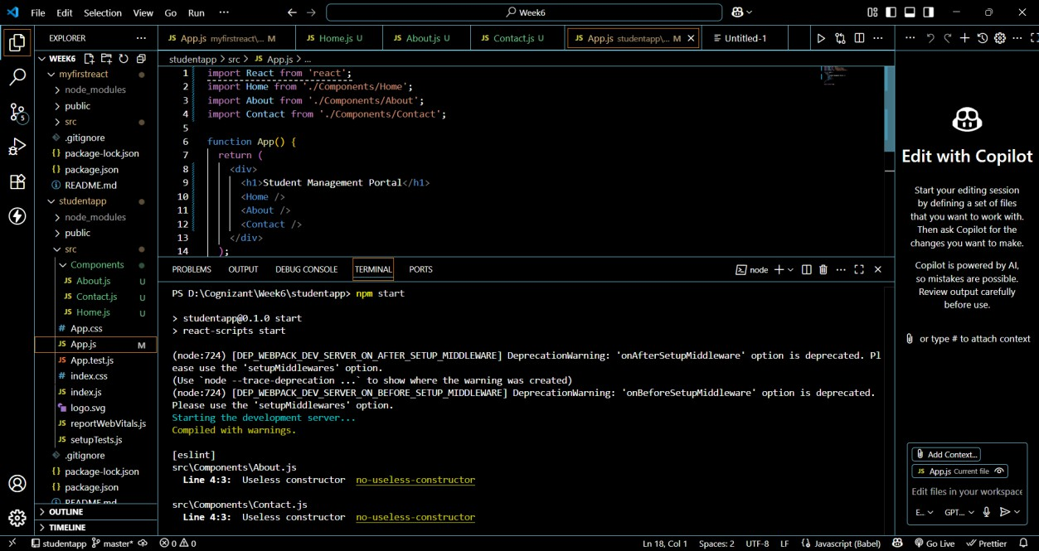In the terminal, inside the StudentApp folder, run: npm start

**Step 9: View Output in Browser** Open a browser and visit: [http://localhost:3000](http://localhost:3000/)

You should see:

Student Management Portal

Welcome to the Home page of Student Management Portal Welcome to the About page of the Student Management Portal Welcome to the Contact page of the Student Management Portal

**Result:**

